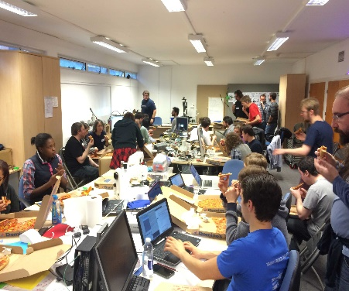
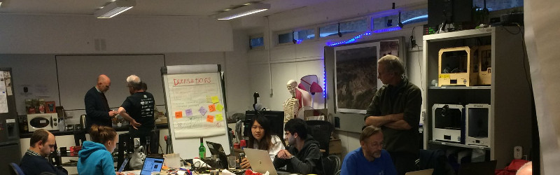

Oxford Hackspace is a welcoming community tools workshop in Oxford city centre, that anyone can join.
In equal parts inventor’s skunkworks, crafter’s paradise, startup accelerator and social change hub, we also run workshops and operate a prototyping service for local businesses to get new products made.
Come work in 3D printing, laser cutting, wood, metal, electronics, sewing, programming, radio, shoemaking, stained glass, social change, or anything else in the company of our lovely, like-minded and skilled community of makers.
We also have coworking space, hire out rooms, and do room rental.
Oxhack seeks to create a space where the only barrier to gaining education in any field is a person's own personal motivation, irrelevant of factors like being poor, young, female, retired, from a minority group, having a learning or physical disability or any other such reason.
If you're motivated to learn, we will find a way to help, whether it be through providing mentors with a background in what you want to learn, pointing you to online resources, offering workshops, or by getting speakers in to talk about the subject.
You're invited to drop by for a tour during our weekly social evenings…
Every Week on Thursdays from 7 to 11pm
Oxford Hackspace
Oxford Centre for Innovation New Road Oxford OX1 1BY
Tel: 01865 261462 Web: oxhack.org Email: hello@oxhack.org
Twitter: @oxfordhackspace Prototyping Enquiries: prototyping@oxhack.org
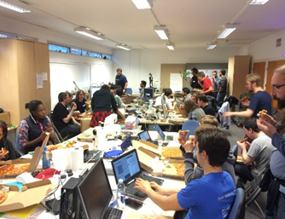
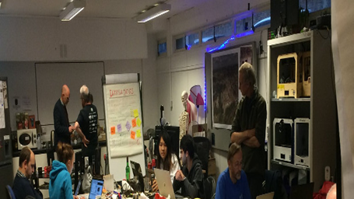

Oxford Hackspace is a welcoming community tools workshop in Oxford city centre, that anyone can join.
In equal parts inventor’s skunkworks, crafter’s paradise, startup accelerator and social change hub, we also run workshops and operate a prototyping service for local businesses to get new products made.
Come work in 3D printing, laser cutting, wood, metal, electronics, sewing, programming, radio, shoemaking, stained glass, social change, or anything else in the company of our lovely, like-minded and skilled community of makers.
We also have coworking space, hire out rooms, and do room rental.
Oxhack seeks to create a space where the only barrier to gaining education in any field is a person's own personal motivation, irrelevant of factors like being poor, young, female, retired, from a minority group, having a learning or physical disability or any other such reason.
If you're motivated to learn, we will find a way to help, whether it be through providing mentors with a background in what you want to learn, pointing you to online resources, offering workshops, or by getting speakers in to talk about the subject.
You're invited to drop by for a tour during our weekly social evenings…
Every Week on Thursdays from 7 to 11pm
Oxford Hackspace
Oxford Centre for Innovation New Road Oxford OX1 1BY
Tel: 01865 261462 Web: oxhack.org Email: hello@oxhack.org
Twitter: @oxfordhackspace Prototyping Enquiries: prototyping@oxhack.org

